Umm Al Qura University

College of Engineering and Computers in Al-Qunfudhah

Department of Computer Science

" Software documentation and technical writing "

PROGRAM NAME: **IHERB**

PREPARED BY:

|  |  |
| --- | --- |
| Name | ID student |
| Aryam yassin alajlani | 444010283 |
| Remas mohammed alsefri | 444006726 |

Dr. Mouna Alofi

**what's iHerb?**

iHerb is an online platform focused on selling health and wellness products, including vitamins, supplements, and organic foods.

**The main 3 tasks that the software can do:**

1- product browsing and search.

2-order management.

3-shipping and delivery management.

**Problems it Solves**

**Limited Availability:** Offers access to products not found in local markets.

**High Prices:** Provides competitive pricing for affordable options.

**Quality Assurance:** Ensures products are original and from reputable brands.

**Needs it Addresses**

**Health:** Meets the growing demand for vitamins and supplements.

**Comfort:** Allows shopping from home, saving time and effort.

**Education:** Offers information and reviews to help customers make informed choices.

**Functional Requirements**

1. **Product Search:** Enable users to search for products by keywords.
2. **User Accounts:** Allow users to create, manage their accounts, and view order history.
3. **Shopping Cart:** Allow users to add, remove, and modify items before checkout.
4. **Secure Payment:** Support multiple payment methods with secure transaction processing.
5. **Order Management:** Provide order confirmations and facilitate returns.

**Non-Functional Requirements**

1. **Performance**: the website load immediately.
2. **Security**: Protect user data with encryption (HTTPS), also login needs password and email or phone number.
3. **Usability**: The interface is easy to use and intuitive.

We conducted a survey on the opinion of 70 users of the application and their satisfaction with it, and these were the results

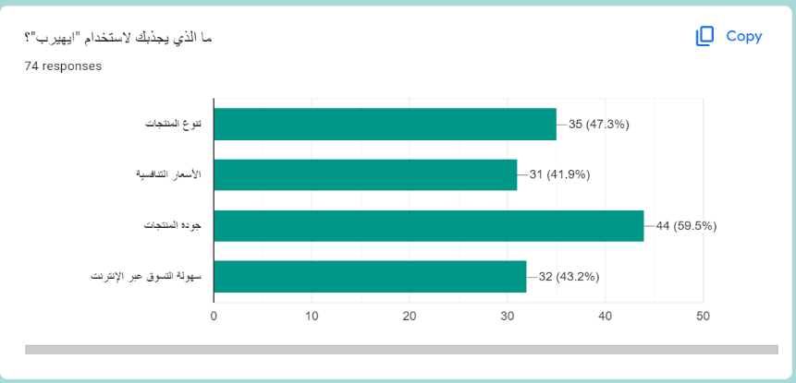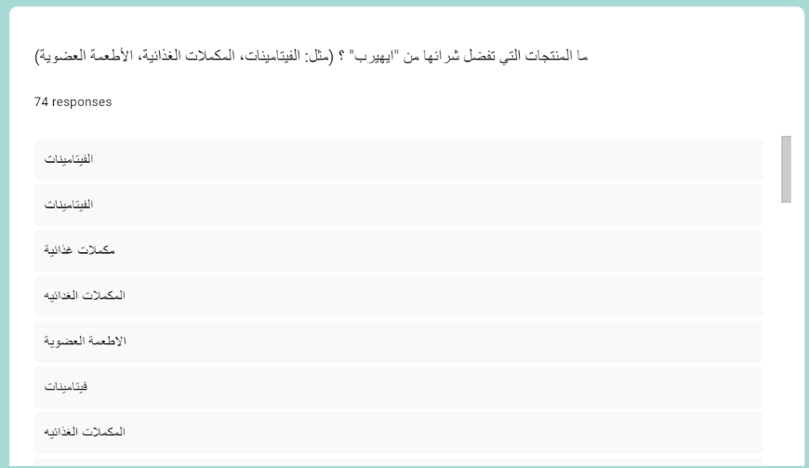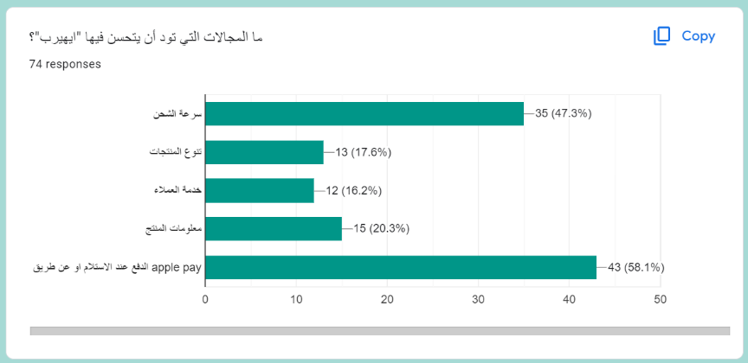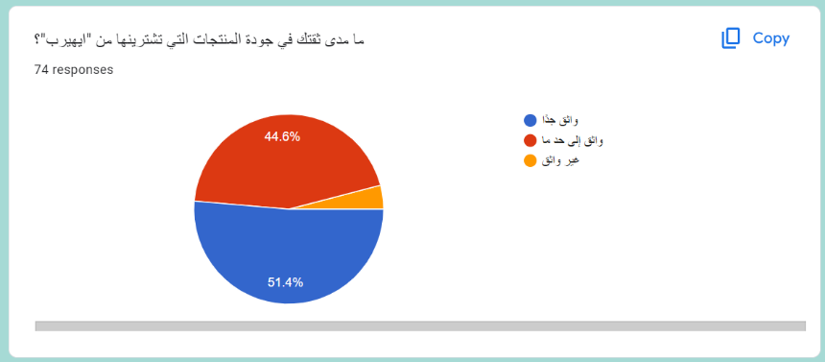(the survey was presented to Saudi customers)

We also asked them what attracts them to use iHerb and the lowest percentage, 41%, was competitive prices, so we suggest offering discounts and offers on products.

58% of users want more payment methods, and 47% want faster delivery

Most users were relatively trust the products provided by the application

We asked users what products they prefer to buy from iHerb and most of the answers were vitamins, nutritional supplements and very few mentioned cosmetics so we suggest improving this aspect and contracting with makeup and cosmetics companies